

**BIGSPD Annual Conference**

Tuesday 10th - Thursday 12th June 2025

The Adelphi Hotel, Liverpool

Ranelagh Place, L3 5UL

**Exhibitor Brochure**

**Exhibition Space**

Exhibition spaces will be located in the lounge area on the ground floor in the Adelphi Hotel.

The exhibition spaces are **3m x 2m** or **2m x 1m.**

**All exhibition packages include:**

* Exhibition stand in exhibition area.
* Access to all conference delegates during breaks and lunch.
* An option to provide delegate bag inserts.
* 2 x complimentary exhibitor passes.
* 2 x complimentary dinner tickets on Wednesday 11th June, held in St George’s Hall, Liverpool.
* Opportunity to meet with members of the BIGSPD Executive Committee.

Please see the floor plan on page 3 for stand locations. Exhibition spaces are available on a first come, first served basis.

**Exhibition Furniture**

Tables, chairs and power sockets can be ordered free of charge for the duration of the conference. Please indicate your requirements on the booking form. **Please note that these tables are not heavy duty and cannot therefore support heavy or large objects.**

Poster boards (1.8m high by 0.9m wide) are available at a cost of £50.00 for the duration of the conference. Subject to availability. Please indicate your requirements on the booking form.

**Payment Terms**

A non-refundable deposit of £500 must be submitted along with the completed form to secure your booking. Bookings made without payment or invoice details will not be considered complete.

**Final Payment must be received by Monday 7th April 2025. An invoice will be sent for the full balance upon booking.**

Payment can be made by credit card or BACS transfer. All payments by BACS transfer must be accompanied by a remittance advice notice sent by e-mail to [bigspd@northernnetworking.co.uk](mailto:bigspd@northernnetworking.co.uk)

Please note AMEX credit cards **cannot** be accepted.

**Cancellation Terms**

**Cancellation of Registration by Exhibitor** - It is a condition of this booking that notification of cancellations and requests for refund should be made in writing to Northern Networking Events Ltd. For cancellations received before 7th April 2025, 70% of the total remittance (not including £500 non-refundable deposit) will be refunded. Cancellations received on or after 7th April 2025, fees will not be refunded.

**Cancellation of Conference/Alteration to Conference** – It is a condition of this booking that Northern Networking Events Ltd and/or its Agents have the right for any reason beyond their control to alter or cancel, without prior notices, the Conference or any of the arrangements, timetables, plans or other items relating directly or indirectly to the Conference and that Northern Networking Events Ltd and/or its Agents shall not, subject as aforementioned, be liable for any loss, damage, expenditure or any inconvenience caused as a result of such alteration or cancellation and in the event of cancellation of the Conference the pre-paid delegate registration fees will be returned in full and Northern Networking Events Ltd and/or its Agents shall not be liable for any loss, damage, expenditure or inconvenience caused as a result of such cancellation.

**Stand Approval**

Any exhibitor wishing to bring a self-build stand for this Conference should provide drawings in advance for approval by the BIGSPD Administration office. Please note all self-build stands are also subject to approval by the venue prior to the event. Should any stand be found to be breaching Health and Safety regulations on the day the exhibitor will be asked to amend the issue prior to the exhibition opening.

**Internet/Wi-Fi**

Wi-Fi is available in the exhibition area for delegates and exhibitors.

**Advertising/ Exhibitors Recognition**

All advertisers and exhibitors will be acknowledged in the conference App.

**Delivery of Equipment and Access to the Adelphi Hotel**

Deliveries for the exhibition must be communicated in advance. You will be advised of the correct delivery address/details that are to be included on the address label and storage arrangements, if needed, subject to availability. All reasonable endeavours for the safekeeping of these items will be taken however, they remain at your own risk and the Adelphi Hotel and BIGSPD will not be held responsible in the event of any loss or damage.

**Exhibition Protocol for The Adelphi Hotel**

Exhibitors Employers & Public Liability -In accordance with the Adelphi Hotel terms and Conditions all exhibitors must carry both employers and public liability to cover their activities whilst onsite. It is requested that public liability to be a minimum limit of indemnity of £10 million and employer’s liability insurance to be a minimum limit of indemnity of £5 million.

**Electrical Safety and Portable Appliance Testing**

It is vital to ensure that electrical equipment brought onto site by all exhibitors has been thoroughly inspected to ensure that it is properly earthed, fused, and cannot become a risk. Any equipment not PAT tested may be removed. Please note laptops, PCs and plasma TVs are not required to be PAT tested but will be visually checked. Power leads for PCs etc. will need to be tested.

Please note there are limits on the amount of power that can be drawn from one socket and adding too many pieces of equipment onto one socket could cause an overload of the system. A visual check will be done on the day to ensure the limits are adhered to; please ensure you request the correct number of sockets for equipment being used.

**Exhibitors - Important Dates Summary**

Monday 19th May 2025 All flyers for the delegate bag must be received by the BIGSPD admin office by 19th May 2024. Please send to: Northern Networking Events, 238 Main Street, Rutherglen, Glasgow G73 2HP

Monday 9th June 2025 All equipment deliveries must be sent to: The Adelphi Hotel, Ranelagh Place, L3 5UL. Please ensure 'FAO of Sales Office', your contact’s name, your organisations name and BIGSPD Conference 2025 are clearly marked on the package.

Tuesday 10th June 2025 All stands should be fully built between 08.00 - 12.00 for registration opening at 12.45.

Thursday 12th June 2025 Exhibition breakdown - Thursday after lunch and be finished by 17.00. All items must be collected from the Adelphi by 17.00 on Friday 13th June 2025.

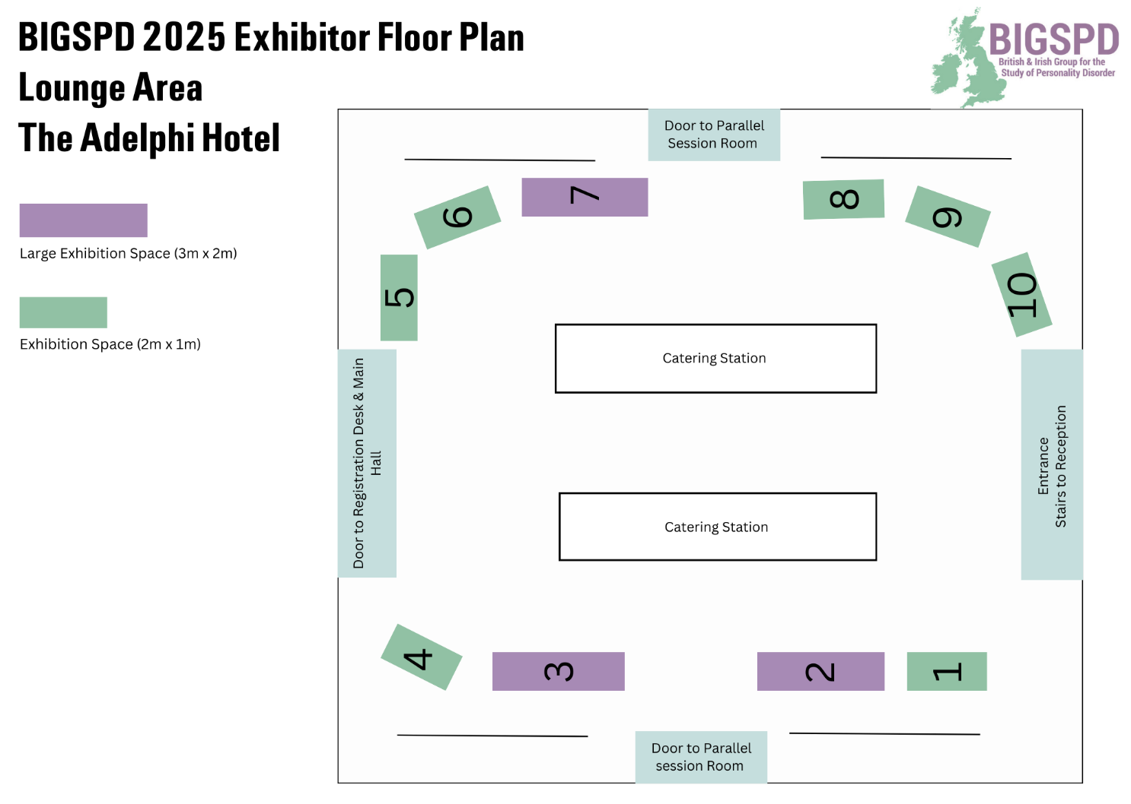

[**Please click here to view what stands are currently available.**](https://www.canva.com/design/DAGXewyFvJU/1B1kcnRebE0zOvCyBJOEfg/view?utm_content=DAGXewyFvJU&utm_campaign=designshare&utm_medium=link2&utm_source=uniquelinks&utlId=h63cff87ed4)

**BIGSPD Annual Conference - Exhibitor Application form**

Tuesday 10th - Thursday 12th June 2025

The Adelphi Hotel, Liverpool

Exhibition spaces are available on a first come, first serve basis. All costs are subject to VAT at the prevailing rate.

Company: ­­­­­­­­­­­­­­_________________________________________________________________________

Main Contact: ­­­­­­­­­­­­­______________________________________________________________________

Stand Person(s): ­­­­­­­­­­­­­____________________________________________________________________

Address: __________________________________________________________________________

Tel: ____________________________ Email: __________________________________________

***Please include with this form the company logo and a short bio for the conference App.***

Please select one of the below options:

|  |  |  |
| --- | --- | --- |
| **Corporate Exhibition Space** | **Cost** | **Total Cost** |
| Large Exhibition Space (3m x 2m) | £3,950.00 |  |
| Exhibition Space (2m x 1m) | £2,700.00 |  |
| NHS Trust Exhibition Space (2m x 1m) | £1,950.00 |  |
| Discretionary Exhibition Space**\*** (2m x 1m) | £700.00 |  |

*Restricted to voluntary sector, community interest or low-income organisations at the discretion of BIGSPD.

|  |  |  |  |
| --- | --- | --- | --- |
| **Sundries** | **Cost** | **Qty** | **Total Cost** |
| Poster Board | £50 |  |  |
| Table (max 1) | Free |  | Free |
| Chair (max 3) | Free |  | Free |
| Power Point (max 1) | Free |  | Free |
| Networking Event on Tuesday 10th June | £60.00 |  |  |
| Dinner on Wednesday 11th June | £75.00 |  |  |
|  |  | Total |  |

If you have any special requirements, please specify below:

|  |  |  |  |
| --- | --- | --- | --- |
| **Advertising Item** | **Cost** | **1st Choice** | **2nd Choice** |
| Pens | £350.00 Supplied by you in agreement with BIGSPD |  |  |
| Notepads | £350.00 Supplied by you in agreement with BIGSPD |  |  |
| Dinner wine - Wednesday 11th June | £500.00 |  |  |
| Dinner entertainment - Wednesday 11th June | £600.00 |  |  |
| Networking Event wine - Tuesday 10th June | £500.00 |  |  |
| Networking Event entertainment - Tuesday 10th June | £600.00 |  |  |
| Tea/coffee breaks  Please specify session: ______________ | £250.00 per session |  |  |
| Flyer for delegate bag | £300.00 |  |  |
| General Advertising (at discretion)  Please specify amount: _________________ | Min. £200.00 |  |  |

|  |
| --- |
| **Invoice Details (if different from above):**  Company: ___________________________________________________________________________________________  Contact: ___________________________________________________________________________________________­  Purchase Order: ______________________________________________________________________________________  Address: _____________________________________________________________________________________________  Tel: ________________________________ Email: __________________________________________________ |

**Please return the completed form to:** [bigspd@northernnetworking.co.uk](mailto:bigspd@northernnetworking.co.uk)

BIGSPD C/O Northern Networking Events Ltd

238 Main Street

Rutherglen

Glasgow, G73 2HP